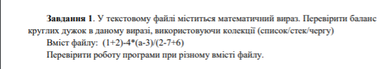

using System;

using System.Collections.Generic;

using System.Linq;

using System.Text;

using System.Threading.Tasks;

using System.IO;

namespace lab7

{

class Program

{

private const string FilePath = "C:\\Users\\Home\\Desktop\\2 курс 2 семестр\\C# labs\\LAB 7\\ConsoleApp2\\ConsoleApp2\\TextFile1.txt";

public static void Main(string[] args)

{

if (!File.Exists(FilePath))

{

Console.WriteLine("File TextFile1.txt does not exist");

Environment.Exit(1);

}

string input = File.ReadAllText(FilePath);

if (String.IsNullOrWhiteSpace(input))

{

Console.WriteLine("File TextFile1.txt is empty");

Environment.Exit(1);

}

var stack = new Stack<int>();

foreach (char element in input)

{

if (element == '(') stack.Push(1);

if (element == ')' && stack.Count != 0) stack.Pop();

}

if (stack.Count == 0)

{

Console.WriteLine("Number of opened brackets equals number of closed brackets");

}

else

{

Console.WriteLine("Number of opened brackets doesn`t equal number of closed brackets");

}

}

}

}



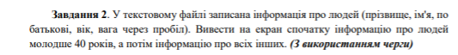

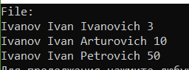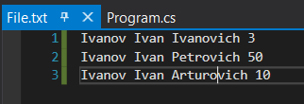

using System;

using System.Collections.Generic;

using System.IO;

namespace lab7

{class Program

{

private const string FilePath = "C:\\Users\\Home\\source\\repos\\lab7\\lab7\\File.txt";

public static void Main(string[] args)

{

var queue = new Queue<string>();

{

if (!File.Exists(FilePath))

{

Console.WriteLine("File File.txt does not exist");

Environment.Exit(1);

}

}

string[] person = File.ReadAllLines(FilePath);

foreach (string element in person)

{

if (int.Parse(element.Split()[3]) < 40)

{

queue.Enqueue(element);

}

}

foreach (string element in person)

{

if (int.Parse(element.Split()[3]) >= 40)

{

queue.Enqueue(element);

}

}

Console.WriteLine("File:");

while(queue.Count!=0)

{

Console.WriteLine(queue.Dequeue());

}

} }}

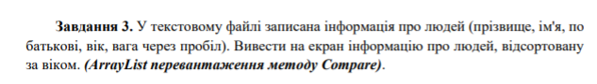

using System;

using System.Collections;

using System.Collections.Generic;

using System.IO;

namespace Task3

{

class PersonComparer : IComparer

{

public int Compare(object x, object y)

{

if (x != null && y != null && x is string && y is string)

{

string person1 = (string)x;

string person2 = (string)y;

return int.Parse(person1.Split()[4]).CompareTo(int.Parse(person2.Split()[4]));

}

return 0;

}

}

public class Program

{

private const string FilePath = "C:\\Users\\Home\\Desktop\\2 курс 2 семестр\\C# labs\\LAB 7\\ConsoleApp2\\ConsoleApp2\\TextFile1.txt";

private static void Exit(string text)

{

Console.WriteLine(text);

Environment.Exit(1);

}

public static void Main(string[] args)

{

if (!File.Exists(FilePath))

{

Exit("File TextFile1.txt doesn`t exist");

}

var arrayList = new ArrayList(File.ReadAllLines(FilePath));

arrayList.Sort(new PersonComparer());

Console.WriteLine("Sorted:");

foreach (string item in arrayList)

{

Console.WriteLine(item);

}

}

}

}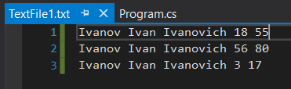

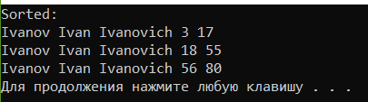

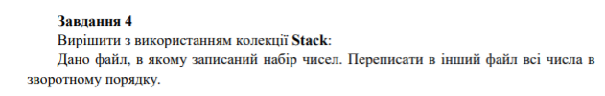

using System;

using System.Collections;

using System.Collections.Generic;

using System.IO;

using System.Linq;

namespace Task4

{

public class Program

{

private const string FilePath = "C:\\Users\\Home\\Desktop\\2 курс 2 семестр\\C# labs\\LAB 7\\ConsoleApp2\\ConsoleApp2\\TextFile1.txt";

private static void Exit(string text)

{

Console.WriteLine(text);

Environment.Exit(1);

}

public static void Main(string[] args)

{

if (!File.Exists(FilePath))

{

Exit("File TextFile1.txt does not exist");

}

var stack = new Stack<string>();

string[] numbers = File.ReadAllText(FilePath).Split();

foreach (var number in numbers)

{

stack.Push(number);

}

Console.WriteLine("Reversed numbers");

while (stack.Count != 0)

{

Console.Write($"{stack.Pop()} ");

}

}

}

}



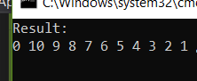

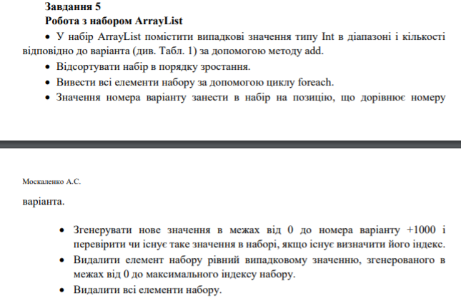



using System;

using System.Collections;

using System.IO;

namespace Task5

{

public class Program

{

private static readonly Random _random = new Random();

private static void PrintAll(ArrayList arrayList)

{

foreach (int item in arrayList)

{

Console.Write($"{item} ");

}

if (arrayList.Count == 0)

{

Console.WriteLine("List is empty");

}

Console.WriteLine();

}

public static void Main(string[] args)

{

var numbers = new ArrayList();

for (var i = 0; i < 2080; i++)

{

numbers.Add(_random.Next(100, 400));

}

numbers.Sort();

Console.WriteLine("Sorted list:");

PrintAll(numbers);

numbers.Insert(1, 2);

var newValue = _random.Next(0, 10 + 1000);

Console.WriteLine(numbers.Contains(newValue)

? "Index of newValue = {numbers.IndexOf(newValue)}"

: "New value doesn`t exist in this list");

newValue = _random.Next(0, numbers.Count - 1);

Console.WriteLine("Delete element with value = {newValue}");

numbers.Remove(newValue);

PrintAll(numbers);

Console.WriteLine("Delete all elements");

numbers.Clear();

PrintAll(numbers);

}

}

}

